**2021 BOTANY — HONOURS**

**Paper : DSE-A-3 (Medicinal and Ethnobotany)**

**Full Marks : 50 T(6th Sm.)-Botany-H/[DSE-A-3]/CBCS**

**The figures in the margin indicate full marks. Candidates are required to give their answers in their own words as far as practicable.**

**1. Answer any five questions:**

**(a) What is Pharmacopoeia? Give an example.**

**A pharmacopoeia is an official publication containing a list of medicinal drugs and their standards, including descriptions of their properties, dosages, methods of preparation, and tests for their identity, purity, and potency. It serves as a reference for ensuring the quality and consistency of pharmaceuticals.**

**\*\*Example**: The United States Pharmacopeia (USP) is an example of a pharmacopoeia. It provides standards for the quality, purity, strength, and consistency of drugs, food ingredients, and dietary supplements manufactured and distributed worldwide.**

**Or//**

**Pharmacopoeia** refers to an official book that contains a list of pharmaceutical compounds, formulae, standards, and quality control tests. It serves as a reference for the preparation, quality, and use of drugs and other substances related to medications. [Pharmacopoeias are essential for ensuring uniformity and maintaining high standards in the pharmaceutical industry1](https://ipc.gov.in/mandates/indian-pharmacopoeia/about-ip.html).

For example, in India, the **Indian Pharmacopoeia (IP)** is the official book of standards for drugs manufactured and marketed in the country. It provides authoritative procedures for drug analysis, specifications for drug identity, purity, and strength. [The IP is legally acceptable during quality assurance and in legal disputes related to drug quality](https://ipc.gov.in/mandates/indian-pharmacopoeia/about-ip.html)

**(b) What are unorganized drugs? Give one example.**

**Unorganized drugs**, also known as **acellular drugs**, are derived from plants or animals but do not contain cellular tissue. They are prepared through intermediary physical processes such as incision, drying, or extraction with water. Here are some examples of unorganized drugs:

1. **Opium**: Derived from the latex of the opium poppy (Papaver somniferum), opium contains alkaloids like morphine and codeine. It is used for pain relief and has a long history in medicine.
2. **Aloe**: Aloe vera gel is extracted from the leaves of the aloe plant (Aloe barbadensis). It is used for its soothing and healing properties, especially for skin conditions.
3. **Catechu**: Obtained from the heartwood of the acacia tree (Acacia catechu), catechu is used in traditional medicine for its astringent and anti-inflammatory effects.
4. **Gums and Resins**: These include substances like acacia gum, tragacanth gum, and resins such as colophony (pine resin) and myrrh. [They have various applications, including in pharmaceuticals and adhesives](https://thepharmacognosy.com/unorganised-plant-drugs/)

**Or//**

**Unorganized drugs refer to natural drugs that are derived from non-cellular or amorphous parts of plants and animals, rather than their organized structures like leaves, roots, or stems. These substances are usually obtained as exudates, extracts, or secretions.**

**\*\*Example**:**

**\*\*Opium** - This is an unorganized drug obtained as a dried latex from the seed capsules of the poppy plant (*Papaver somniferum*). It contains several alkaloids, including morphine, which are used for their analgesic properties.**

**(c) Write one therapeutic use of Diosgenin and state the chemical nature of it.**

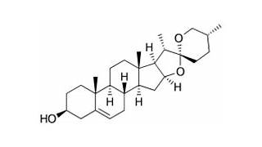

**Diosgenin** is a steroidal saponin found in various plants, including *Dioscorea opposita*. It has been extensively studied for its pharmacological effects. Here’s one therapeutic use and its chemical nature:

1. **Therapeutic Use**:
   * **Anti-Cancer Activity**: Diosgenin has shown promise in preclinical studies as an anti-cancer agent. [It exhibits effects that may help inhibit cancer cell growth and proliferation](https://clinphytoscience.springeropen.com/articles/10.1186/s40816-021-00288-y)[1](https://clinphytoscience.springeropen.com/articles/10.1186/s40816-021-00288-y).
2. **Chemical Nature**:
   * Diosgenin is a **white needle-like crystal** or light powder.
   * It serves as the **active ingredient** of Chinese medicine steroidal saponin.
   * Diosgenin is **widely present** in legumes and various species of *Dioscorea* (yam plants).
   * [Importantly, it acts as a **precursor** for the synthesis of many steroidal drugs in the pharmaceutical industry2](https://www.scielo.br/j/cta/a/TcC5sqvmdLs9tqbKLVxd7Fg/).

Or//

**Therapeutic Use of Diosgenin**:

Diosgenin is primarily used as a precursor in the synthesis of steroid hormones, such as progesterone and cortisone. These hormones have various therapeutic applications, including in hormone replacement therapy, contraceptive formulations, and the treatment of inflammatory and autoimmune conditions.

**Chemical Nature of Diosgenin**:

Diosgenin is a steroidal saponin. It has a steroid structure with a sapogenin backbone, which includes a spirostan (spiroketal) ring system. This chemical structure allows it to serve as a key starting material for the synthesis of various steroid hormones.

**(d) What are curcuminoids? Name the source plant.**

**\*\*Curcuminoids** are a group of natural phenolic compounds with potent antioxidant and anti-inflammatory properties. They are the active constituents of turmeric and include compounds such as curcumin, demethoxycurcumin, and bisdemethoxycurcumin.**

**\*\*Source Plant**:**

**The source plant for curcuminoids is **turmeric**, which is scientifically known as *Curcuma longa*. Turmeric is a rhizomatous herbaceous perennial plant belonging to the ginger family, Zingiberaceae.**

**(e) What is ‘gutta-percha’?**

**\*\*Gutta-percha** is a rigid, natural latex produced from the sap of certain trees, particularly the *Palaquium* genus in the family Sapotaceae. It is similar to rubber but is less elastic and more brittle.**

**\*\*Common Uses**:**

**- **Dentistry**: Used as a permanent filling material in root canal therapy.**

**- **Electrical Insulation**: Historically used for insulating underwater cables due to its insulating properties and resistance to water.**

**(f) Give one example each from macrobotanical and microbotanical evidences of Paleoethnobotany.**

**\*\*Macrobotanical Evidence Example**:**

- **Charred Seeds**: These are large plant remains such as seeds, nuts, and wood fragments that can be seen without a microscope. For example, charred wheat grains found at an archaeological site can provide information about ancient agricultural practices.

**\*\*Microbotanical Evidence Example**:**

**-** **Pollen Grains**: These are microscopic plant remains that require a microscope to be seen. For instance, fossilized pollen grains recovered from soil samples can help reconstruct past climates and vegetation patterns**.**

**(g) What do you mean by Unani system of medicine?**

**The **Unani system of medicine** is a traditional healing system based on ancient Greek medicine and further developed by Arab and Persian physicians. It focuses on balancing the body's four humors (blood, phlegm, yellow bile, and black bile) and individual temperaments. Treatments include herbal medicines, dietary recommendations, and regimenal therapies like massage and cupping.**

**(h) Why terpenes are referred to as isoprenoids?**

Terpenes are referred to as isoprenoids because they are derived from units of isoprene (C5H8), a five-carbon molecule. Isoprene units can combine in various ways to form the diverse structures of terpenes, which are a large and diverse class of organic compounds found in plants and some microorganisms.

**2. Answer any two of the following:**

**(a) Write a short note on principles and applications of Ayurveda system of medicine.**

**\*\*Principles and Applications of Ayurveda\*\***

**Ayurveda, an ancient healing system originating in India, operates on holistic principles aiming to harmonize body, mind, and spirit. Its core principles include the balance of bodily doshas (Vata, Pitta, Kapha), the interconnectedness of the individual with nature, and the emphasis on prevention of disease.**

**\*\*Principles**:**

**1. **Tridosha Theory**: Ayurveda postulates that health is maintained when the three doshas—Vata (air), Pitta (fire), and Kapha (water)—are in equilibrium. Imbalances lead to illness.**

**2. **Panchamahabhutas**: According to Ayurveda, everything in the universe, including the human body, is composed of five elements: ether, air, fire, water, and earth.**

**3. **Dhatus and Malas**: Ayurveda emphasizes the balance of dhatus (tissues) and malas (wastes) in the body for optimal health.**

**4. **Prakriti**: Each individual has a unique constitution or Prakriti, determined by the dominance of doshas. Understanding one's Prakriti guides personalized health recommendations.**

**\*\*Applications**:**

**1. **Herbal Remedies**: Ayurveda employs a wide range of herbs and plant-based medicines to treat various ailments. These include formulations like churnas (powders), kwathas (decoctions), and tailas (oils).**

**2. **Diet and Lifestyle**: Ayurveda emphasizes the importance of diet and lifestyle in maintaining health and preventing disease. It provides guidelines on suitable diets, daily routines, and seasonal regimens based on an individual's constitution.**

**3. **Yoga and Meditation**: Ayurveda incorporates yoga and meditation practices to promote physical, mental, and spiritual well-being. Asanas (postures), pranayama (breath control), and meditation are used to balance doshas and enhance vitality.**

**4. **Panchakarma**: This detoxification and rejuvenation therapy involves five therapeutic procedures: Vamana (emesis), Virechana (purgation), Basti (enema), Nasya (nasal administration), and Raktamokshana (bloodletting). It aims to cleanse the body of toxins and restore doshic balance.**

**5. **Ayurvedic Massage and Therapies**: Various massage techniques like Abhyanga (oil massage) and Shirodhara (pouring of medicated oil on the forehead) are used for relaxation, rejuvenation, and therapeutic purposes.**

**6. **Rasayana and Vajikarana**: These are branches of Ayurveda focused on rejuvenation and aphrodisiac therapies, respectively, aiming to enhance longevity, vitality, and reproductive health.**

**In conclusion, Ayurveda offers a comprehensive approach to health and healing, integrating natural remedies, lifestyle practices, and spiritual teachings to promote balance and well-being. Its principles and applications continue to be relevant in modern healthcare, emphasizing personalized, holistic care.**

**(b) Write a brief note on the following: (i) organoleptic evaluation (ii) biological evaluation. 5 2½+2½**

(i) \*\***Organoleptic Evaluation**\*\*

Organoleptic evaluation is a sensory analysis method used to assess the characteristics of substances based on human senses, particularly sight, smell, taste, touch, and sometimes sound. It plays a crucial role in various industries, including food, pharmaceuticals, cosmetics, and agriculture, where the quality and acceptability of products are determined by sensory attributes.

**Key Aspects**:

1. **Visual Inspection**: Involves assessing the appearance, color, shape, and size of the sample. For example, in food products, visual inspection can indicate freshness, ripeness, or presence of defects.

2. **Olfactory Examination**: Evaluation of the aroma or smell of the sample. Aroma can provide information about freshness, ripeness, fermentation, or spoilage.

3. **Taste Testing**: Involves sampling the product to evaluate its taste characteristics, such as sweetness, sourness, bitterness, saltiness, or umami. Taste evaluation is essential in food and beverage industries for product development and quality control.

4. **Texture Analysis**: Assessment of the texture, consistency, firmness, and mouthfeel of the sample. This includes tactile sensations perceived by touch, such as hardness, softness, roughness, or smoothness.

5. **Sound Evaluation**: In some cases, particularly in industries like agriculture, the sound produced by tapping or shaking the sample can provide information about its quality. For example, the sound of a ripe fruit may differ from that of an unripe one.

**Applications**:

1. **Quality Control**: Organoleptic evaluation is used to assess the quality, freshness, and acceptability of products before they are marketed or consumed. This ensures that products meet the desired standards and specifications.

2. **Product Development**: Sensory analysis helps in the development of new products by understanding consumer preferences and optimizing sensory attributes to enhance product appeal.

3. **Quality Assurance**: It plays a crucial role in ensuring consistency and uniformity in the sensory characteristics of products over time and across batches.

4. **Safety Assessment**: Organoleptic evaluation can also indicate potential safety hazards or contamination in products. For example, off-odors or off-flavors may indicate microbial spoilage or chemical contamination.

5. **Market Research**: Sensory testing is used in market research to understand consumer preferences, perceptions, and buying behavior, guiding marketing strategies and product positioning.

In conclusion, organoleptic evaluation is a valuable tool for assessing the sensory properties of substances, providing essential information about their quality, safety, and acceptability. It complements instrumental analysis methods and is integral to various stages of product development, quality control, and consumer satisfaction.

(ii) **Biological Evaluation**

Biological evaluation is a process used to assess the safety and efficacy of substances or products by studying their interactions with living organisms. This evaluation is essential in various fields such as pharmaceuticals, biotechnology, agriculture, and environmental science.

**Key Aspects**:

1. **Toxicity Testing**: Biological evaluation includes assessing the toxicity of substances to determine their harmful effects on living organisms. This involves studying acute and chronic toxicity, genotoxicity, carcinogenicity, and reproductive toxicity.

2. **Efficacy Studies**: In pharmaceuticals and agrochemicals, biological evaluation examines the effectiveness of substances in achieving the desired therapeutic or pesticidal effects. This includes in vitro studies, animal testing, and clinical trials in humans.

3. **Pharmacokinetics and Pharmacodynamics**: Biological evaluation involves studying the absorption, distribution, metabolism, and excretion (ADME) of drugs or chemicals in living organisms. Pharmacodynamic studies assess the physiological effects and mechanisms of action of substances.

4. **Biocompatibility Testing**: In medical devices and implants, biological evaluation evaluates the compatibility of materials with living tissues and the body's response to implants. This includes assessing inflammation, tissue response, and the risk of adverse reactions.

5. **Environmental Impact Assessment**: Biological evaluation assesses the impact of chemicals, pollutants, and genetically modified organisms (GMOs) on ecosystems, wildlife, and human health. This includes studies on environmental toxicity, bioaccumulation, and ecological risks.

**Applications**:

1. **Drug Development**: Biological evaluation is integral to the development of pharmaceuticals, including preclinical studies to assess safety and efficacy, as well as clinical trials to evaluate therapeutic effects and side effects in humans.

2. **Agrochemicals and Pesticides**: In agriculture, biological evaluation determines the safety and effectiveness of pesticides, herbicides, and fertilizers, ensuring minimal harm to humans, animals, and the environment.

3. **Biomedical Research**: Biological evaluation contributes to understanding disease mechanisms, drug targets, and treatment strategies through in vitro and in vivo studies using cell cultures, animal models, and human subjects.

4. **Regulatory Compliance**: Regulatory authorities require biological evaluation data to assess the safety and efficacy of substances before approval for commercial use. This includes compliance with guidelines such as Good Laboratory Practices (GLP) and Good Clinical Practices (GCP).

5. **Environmental Protection**: Biological evaluation helps in assessing the environmental impact of chemicals, pollutants, and GMOs, guiding environmental policies and regulations to mitigate risks and protect ecosystems.

In summary, biological evaluation plays a critical role in assessing the safety, efficacy, and environmental impact of substances, informing decision-making in research, development, regulation, and environmental management. It involves interdisciplinary approaches combining biology, pharmacology, toxicology, and environmental science to ensure the protection of human health and the environment.

**(c) What do you mean by polyherbal formulations? Cite an example of polyherbal formulation effective against a particular disease. 4+1**

**Polyherbal Formulations**

Polyherbal formulations refer to medicinal products composed of a combination of two or more herbs or plant extracts. This approach to herbal medicine has been practiced for centuries in various traditional healing systems, including Ayurveda, Traditional Chinese Medicine (TCM), and Unani medicine. Polyherbal formulations offer several advantages over single herb preparations, including synergistic therapeutic effects, broader spectrum of action, reduced side effects, and enhanced bioavailability.

**Key Aspects**:

1. **Synergistic Effects**: Combining multiple herbs in a formulation can result in synergistic interactions, where the combined effect is greater than the sum of individual effects. This synergy may enhance therapeutic efficacy and produce more profound healing outcomes.

2. **Comprehensive Treatment**: Polyherbal formulations often target multiple aspects of a health condition, addressing its underlying causes, symptoms, and associated complications. This holistic approach supports the body's natural healing processes and promotes overall well-being.

3. **Customization and Personalization**: Herbalists and practitioners of traditional medicine can tailor polyherbal formulations to meet the individual needs and constitution of patients. By selecting specific herbs and adjusting their proportions, formulations can be customized for different health conditions and patient profiles.

4. **Reduced Side Effects**: By combining herbs with complementary actions and mechanisms of action, polyherbal formulations may help mitigate potential side effects associated with high doses or prolonged use of single herbs. This can improve tolerability and safety, particularly in long-term treatment regimens.

5. **Broader Spectrum of Action**: Polyherbal formulations may exhibit a broader spectrum of pharmacological activities compared to single herb preparations. This can be advantageous in treating multifactorial conditions or complex diseases with diverse underlying mechanisms.

6. **Enhanced Bioavailability**: Some herbs in a polyherbal formulation may enhance the absorption, distribution, metabolism, and excretion (ADME) of other herbs, leading to improved bioavailability and therapeutic efficacy. This may result from synergistic interactions or the presence of bioenhancers and adjuvants.

**Applications**:

1. **Traditional Medicine Systems**: Polyherbal formulations are commonly used in traditional healing systems such as Ayurveda, TCM, and Unani medicine to treat a wide range of acute and chronic health conditions, including respiratory disorders, digestive ailments, cardiovascular diseases, and musculoskeletal disorders.

2. **Modern Herbal Medicine**: In modern herbal medicine and phytotherapy, polyherbal formulations are gaining popularity as natural alternatives or adjuncts to conventional treatments. They are used in various forms, including capsules, tablets, tinctures, teas, and topical preparations.

3. **Nutraceuticals and Dietary Supplements**: Polyherbal formulations are increasingly utilized in the formulation of nutraceuticals and dietary supplements aimed at supporting overall health, boosting immunity, improving vitality, and preventing lifestyle-related diseases.

4. **Clinical Research and Development**: There is growing interest in scientific research and clinical trials to investigate the safety, efficacy, and mechanisms of action of polyherbal formulations. This includes studies on pharmacokinetics, pharmacodynamics, toxicology, and clinical outcomes.

In conclusion, polyherbal formulations represent a versatile and effective approach to herbal medicine, offering synergistic therapeutic effects, comprehensive treatment, customization, and reduced side effects. They bridge traditional knowledge with modern research and have the potential to play a significant role in integrative healthcare and personalized medicine.

**One example of a polyherbal formulation effective against a particular disease is **Trikatu**, an Ayurvedic blend of Pippali (Piper longum), Maricha (Piper nigrum), and Shunthi (Zingiber officinale). It aids digestion, stimulates metabolism, and relieves digestive discomfort. Studies support its efficacy in enhancing gastrointestinal function and respiratory health, showcasing the benefits of polyherbal formulations**.

**3. Answer any three of the following:**

**(a) Explain with an example how quantitative microscopy is used in drug evaluation. Discuss the classification of drugs on the basis of chemical constitution and therapeutic effect. Cite a few merits and demerits based on these classifications. 2+3+3+1+1**

**Quantitative Microscopy in Drug Evaluation**

Quantitative microscopy is a technique used to measure various properties of drug particles or formulations under a microscope. It provides quantitative data on parameters such as particle size, shape, distribution, and morphology, which are crucial for assessing the quality, performance, and stability of pharmaceutical products. Here's an example of how quantitative microscopy is used in drug evaluation:

**Example: Particle Size Analysis of Inhalable Drug Formulations**

Inhalable drug formulations, such as dry powder inhalers (DPIs) and metered-dose inhalers (MDIs), deliver medication directly to the lungs for the treatment of respiratory diseases like asthma and chronic obstructive pulmonary disease (COPD). Particle size distribution plays a critical role in the effectiveness of these formulations, as it affects the deposition and absorption of the drug in the lungs.

the classification of drugs based on both their  **chemical constitution** and their **therapeutic effects**. Understanding these classifications is essential for ensuring safe and effective drug use.

**Classification Based on Chemical Constitution:**

1. **Organic vs. Inorganic Drugs**:
   * **Organic Drugs**: These contain carbon atoms in their molecular structure. Most drugs fall into this category. Examples include antibiotics, analgesics, and antihypertensives.
   * **Inorganic Drugs**: These do not contain carbon atoms. They may include elements other than carbon, such as metals. [However, inorganic drugs are less common in modern medicine](https://www.pharmaacademias.com/chemical-classification-of-drugs/)[1](https://www.pharmaacademias.com/chemical-classification-of-drugs/).
2. **Functional Groups**:
   * Functional groups within a drug’s chemical structure play a crucial role in determining its properties and interactions. Examples of functional groups include hydroxyl (-OH), amino (-NH₂), and carboxyl (-COOH) groups.

**Classification Based on Therapeutic Effect:**

1. **Pharmacological Effect**:
   * Drugs can be classified based on how they affect the body’s cells and tissues. This classification considers the specific biochemical changes caused by the drug (pharmacokinetics).
   * Examples:
     + **Analgesics**: Reduce pain perception.
     + **Anti-inflammatory Drugs**: Reduce inflammation in the body.
     + **Antihypertensives**: Lower blood pressure.
     + **Antidepressants**: Improve mood and treat depression.
     + **Antibiotics**: Kill or inhibit the growth of bacteria.
     + **Antacids**: Neutralize stomach acid.
2. **Drug Action**:
   * Different drugs have distinct mechanisms of action (how they generate a response). For example:
     + **Beta-Blockers**: Block beta receptors to reduce heart rate and blood pressure.
     + **ACE Inhibitors**: Inhibit angiotensin-converting enzyme (ACE) to lower blood pressure.
     + **Vasodilators**: Dilate blood vessels to improve blood flow.
3. **Molecular Targets**:
   * Some drugs specifically target biomolecules within the body. These include proteins, lipids, carbohydrates, and nucleic acids.
   * Examples:
     + **Statins**: Target enzymes involved in cholesterol synthesis.
     + **Antiviral Drugs**: Target viral enzymes or proteins.
     + **Hormones**: Interact with specific receptors in the body.

Remember that a single drug can belong to multiple categories based on its mechanism of action, physiological effects, and chemical structure. [Drug classification ensures safe and effective use, maximizing benefits while minimizing risks](https://www.pharmaacademias.com/chemical-classification-of-drugs/)[2](https://www.vedantu.com/jee-main/chemistry-classification-of-drugs)[3](https://www.verywellhealth.com/drug-classes-1123991)[4](https://www.embibe.com/exams/classification-of-drugs/)

Or//

**Classification of Drugs based on Chemical Constitution and Therapeutic Effect**

**Chemical Constitution Classification**:

1. **Organic Compounds**: Majority of drugs are organic compounds derived from living organisms or synthesized chemically. They can be further classified based on their chemical structure, such as:

- **Alkaloids**: Derived from plants, alkaloids include morphine, caffeine, and nicotine.

- **Steroids**: Hormones and anti-inflammatory drugs like cortisone and testosterone fall under this category.

- **Amino Acids and Peptides**: Drugs like insulin and antibiotics such as penicillin are composed of amino acids or peptides.

- **Terpenes and Terpenoids**: Natural compounds found in essential oils and herbal medicines, like menthol and curcumin, belong to this group.

2. **Inorganic Compounds**: Some drugs are composed of inorganic elements or compounds, such as:

- **Salts**: Inorganic salts of elements like sodium, potassium, and calcium are used as drugs, such as sodium bicarbonate and potassium chloride.

- **Metals and Metalloids**: Certain metals and metalloids have medicinal properties, like lithium for bipolar disorder and arsenic for treating specific infections.

**Therapeutic Effect Classification**:

1. **Based on Action Mechanism**:

- **Analgesics**: Drugs that relieve pain without causing loss of consciousness, such as aspirin and ibuprofen.

- **Antibiotics**: Substances that inhibit the growth of microorganisms or kill bacteria, fungi, or parasites, including penicillin and erythromycin.

- **Antidepressants**: Medications used to treat depression and mood disorders, like selective serotonin reuptake inhibitors (SSRIs) and tricyclic antidepressants.

- **Antihypertensives**: Drugs that lower blood pressure, including beta-blockers, calcium channel blockers, and angiotensin-converting enzyme (ACE) inhibitors.

2. **Based on Therapeutic Use**:

- **Cardiovascular Drugs**: Medications for treating heart and blood vessel diseases, such as beta-blockers, statins, and antiarrhythmics.

- **Antidiabetic Drugs**: Medications used to manage diabetes mellitus, including insulin, metformin, and sulfonylureas.

- **Antineoplastic Drugs**: Treatments for cancer, including chemotherapy drugs like cisplatin, targeted therapies, and immunotherapy agents.

- **Psychotropic Drugs**: Medications for treating mental disorders, such as antipsychotics, anxiolytics, and mood stabilizers.

3. **Based on Pharmacological Action**:

- **Agonists and Antagonists**: Drugs that mimic or block the action of endogenous substances, like opioid agonists for pain relief and beta-blockers as antagonists for blood pressure control.

- **Vasoconstrictors and Vasodilators**: Substances that constrict or dilate blood vessels, used in conditions like hypertension and angina.

4. **Based on Organ or System Target**:

- **Respiratory Drugs**: Medications for respiratory conditions, such as bronchodilators for asthma and chronic obstructive pulmonary disease (COPD).

- **Gastrointestinal Drugs**: Treatments for gastrointestinal disorders, including antacids for heartburn and proton pump inhibitors (PPIs) for ulcers.

In conclusion, drugs can be classified based on their chemical constitution, including organic and inorganic compounds, as well as their therapeutic effects, which encompass various mechanisms of action, therapeutic uses, and pharmacological targets. This classification aids in understanding drug properties, prescribing practices, and therapeutic management of diseases.

The merits and demerits of drug classifications based on **chemical constitution** and **therapeutic effect**:

1. **Merits**:
   * **Chemical Constitution**:
     + **Precision**: Classifying drugs based on their chemical structure allows precise identification and understanding of their properties.
     + **Predictability**: Similar chemical structures often lead to similar pharmacological actions, aiding in predicting drug behavior.
     + **Drug Development**: Insights from chemical classification guide the design of new drugs.
   * **Therapeutic Effect**:
     + **Clinical Relevance**: Therapeutic classifications help healthcare professionals choose appropriate drugs for specific conditions.
     + **Treatment Tailoring**: Understanding therapeutic effects allows personalized treatment plans.
     + **Research and Education**: It facilitates research and education in pharmacology.
2. **Demerits**:
   * **Chemical Constitution**:
     + **Complexity**: Some drugs defy straightforward classification due to multifaceted structures.
     + **Exceptions**: Not all drugs fit neatly into predefined chemical categories.
     + **Limited Insight**: Chemical classification alone doesn’t reveal all aspects of drug action.
   * **Therapeutic Effect**:
     + **Overlap**: Some drugs have multiple therapeutic effects, making precise classification challenging.
     + **Side Effects**: Therapeutic effects may come with unintended adverse effects.
     + **Individual Variability**: Responses vary among individuals, affecting therapeutic outcomes.

Remember that a holistic approach considers both chemical and therapeutic aspects to optimize drug use.

**(b) Mention the source plants, parts used, one therapeutic application and the chemical nature of the following drugs: (½+½+½+½)×5 (i) Atropine (ii) Catechin (iii) Solasodine (iv) Capsaicin (v) Gingerol.**

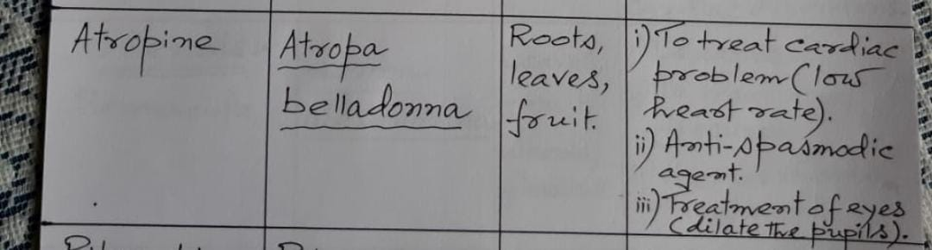

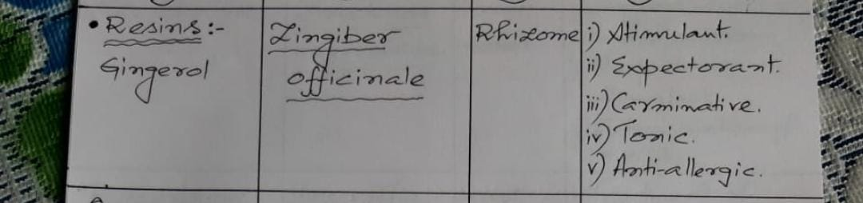

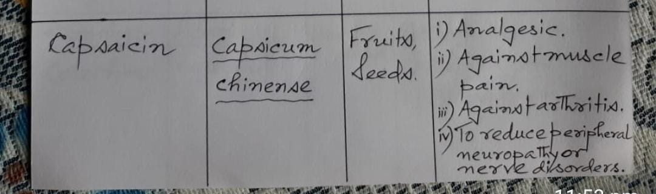

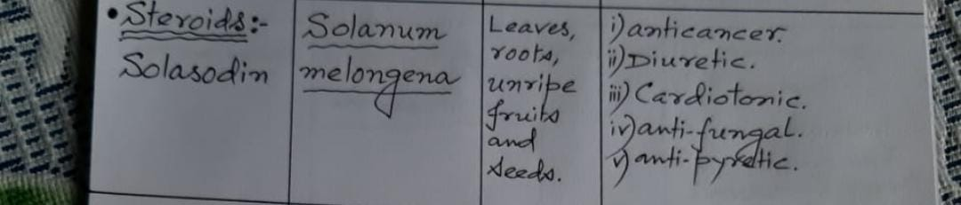



**(c) Write the protective action of phenolics and terpenoids against pathogenic microbes and herbivores**

**\*\*Protective Action of Phenolics and Terpenoids Against Pathogenic Microbes\*\***

**\*\*Phenolics**:**

**Phenolic compounds are a diverse group of plant secondary metabolites known for their antioxidant, antimicrobial, and anti-inflammatory properties. Their protective action against pathogenic microbes is attributed to several mechanisms:**

**1. **Disruption of Cell Membranes**: Phenolic compounds can disrupt microbial cell membranes by interacting with lipids and proteins, leading to leakage of intracellular contents and cell lysis. This disrupts the integrity and function of microbial cells, inhibiting their growth and proliferation.**

**2. **Inhibition of Enzyme Activity**: Phenolics can inhibit the activity of microbial enzymes essential for metabolic processes, such as glycolysis, respiration, and DNA replication. By interfering with enzyme function, phenolics disrupt microbial metabolism and energy production, leading to microbial growth inhibition.**

**3. **Oxidative Stress Induction**: Phenolic compounds can generate reactive oxygen species (ROS) within microbial cells through redox reactions. Excessive ROS accumulation leads to oxidative stress, causing damage to microbial cell components like DNA, proteins, and lipids, ultimately leading to cell death.**

**4. **Interference with Quorum Sensing**: Some phenolic compounds have been found to interfere with microbial quorum sensing, a cell-to-cell communication mechanism used by bacteria to coordinate gene expression and regulate virulence factors. By disrupting quorum sensing, phenolics can inhibit microbial pathogenicity and biofilm formation.**

**5. **Modulation of Host Immune Response**: Certain phenolic compounds possess immunomodulatory properties, enhancing the host immune response against microbial infections. They can stimulate the production of antimicrobial peptides, cytokines, and chemokines, promoting microbial clearance and resolution of infection.**

**\*\*Terpenoids**:**

**Terpenoids are a diverse class of natural compounds derived from isoprene units, found abundantly in essential oils, resins, and plant extracts. They exhibit a wide range of biological activities, including antimicrobial effects against pathogenic microbes, through the following mechanisms:**

**1. **Disruption of Cell Membranes**: Similar to phenolics, terpenoids can disrupt microbial cell membranes by interacting with lipids and proteins. This disrupts membrane integrity, leading to leakage of cellular contents and eventual cell death.**

**2. **Inhibition of Enzyme Activity**: Terpenoids can inhibit the activity of microbial enzymes involved in essential metabolic pathways, such as cell wall synthesis, protein synthesis, and nucleic acid replication. This disrupts microbial growth and proliferation.**

**3. **Pore Formation in Cell Membranes**: Some terpenoids, particularly sesquiterpenes and diterpenes, have been shown to induce the formation of pores in microbial cell membranes. This disrupts membrane integrity, leading to ion leakage and eventual cell death.**

**4. **Antioxidant and ROS Scavenging Activity**: Certain terpenoids possess antioxidant properties and can scavenge ROS generated by microbial cells during oxidative stress. By neutralizing ROS, terpenoids protect host cells from oxidative damage and contribute to microbial inhibition.**

**5. **Modulation of Virulence Factors**: Terpenoids can modulate microbial virulence factors, such as adhesion molecules, toxins, and biofilm formation, thereby reducing microbial pathogenicity and enhancing host defense mechanisms against infection.**

**In summary, phenolics and terpenoids exert protective action against pathogenic microbes through multiple mechanisms, including membrane disruption, enzyme inhibition, oxidative stress induction, and modulation of virulence factors. Their broad spectrum antimicrobial activity and diverse mechanisms of action make them valuable candidates for the development of novel antimicrobial agents and natural remedies for infectious diseases.**

**\*\*Protective Action of Phenolics and Terpenoids Against Herbivores\*\***

**\*\*Phenolics**:**

**Phenolic compounds play a crucial role in plant defense against herbivores, serving as deterrents, repellents, and toxins. Their protective action against herbivores involves several mechanisms:**

**1. **Bitterness and Astringency**: Many phenolic compounds impart bitter or astringent tastes to plant tissues, deterring herbivores from feeding. These compounds can act as feeding deterrents, reducing herbivore consumption of leaves, stems, and fruits.**

**2. **Toxicity and Antinutritional Effects**: Certain phenolic compounds, such as tannins, flavonoids, and alkaloids, exhibit toxic effects on herbivores when ingested in high concentrations. These compounds interfere with herbivore digestion, absorption of nutrients, and metabolism, leading to reduced herbivore fitness and performance.**

**3. **Protein Precipitation**: Tannins, a class of phenolic compounds, can bind to dietary proteins in the herbivore's digestive tract, forming insoluble complexes that are difficult to digest. This reduces the availability of essential nutrients and amino acids, impairing herbivore growth and development.**

**4. **Antifeedant Activity**: Some phenolic compounds have antifeedant properties, causing aversion or reduced feeding behavior in herbivores. This is mediated by sensory receptors in the herbivore's mouthparts or digestive system, which perceive the presence of bitter or noxious compounds and signal avoidance behavior.**

**5. **Induction of Defense Pathways**: Phenolic compounds can trigger plant defense responses, including the production of secondary metabolites and activation of signaling pathways involved in defense against herbivores. This enhances the plant's ability to withstand herbivore attack and minimize damage.**

**\*\*Terpenoids**:**

**Terpenoids are another class of plant secondary metabolites with diverse chemical structures and defensive functions against herbivores. Their protective action involves several mechanisms:**

**1. **Repellent and Deterrent Effects**: Some terpenoids, such as monoterpenes and sesquiterpenes, emit volatile compounds with strong odors or flavors that repel or deter herbivores from feeding. These compounds signal the presence of defensive chemicals and discourage herbivore attack.**

**2. **Toxicity and Antifeedant Activity**: Many terpenoids exhibit toxic or antifeedant effects on herbivores when ingested. These compounds disrupt herbivore digestion, metabolism, or nervous system function, leading to reduced feeding behavior, growth inhibition, or mortality.**

**3. **Contact and Systemic Toxicity**: Terpenoids can exert toxic effects on herbivores upon contact with plant tissues or ingestion. Some terpenoids act locally, causing irritation or damage to herbivore mouthparts, while others are absorbed systemically and distributed throughout the herbivore's body, affecting various physiological processes.**

**4. **Inhibition of Digestive Enzymes**: Certain terpenoids can inhibit the activity of digestive enzymes in the herbivore's gut, impairing nutrient digestion and absorption. This reduces the availability of essential nutrients for herbivore growth and reproduction, leading to decreased fitness and survival.**

**5. **Indirect Defense Mechanisms**: Terpenoids can also indirectly defend plants against herbivores by attracting natural enemies, such as predators or parasitoids, that feed on herbivores or their eggs. This forms part of the plant's indirect defense strategy, enhancing herbivore mortality and reducing damage to plant tissues.**

**In summary, phenolics and terpenoids play crucial roles in plant defense against herbivores through a variety of mechanisms, including toxicity, deterrence, antifeedant activity, and induction of defense pathways. Their diverse chemical structures and defensive functions contribute to the overall fitness and survival of plants in natural ecosystems.**

**(d) What do you mean by folk medicine? Write some remedies from natural sources for the treatment of: (i) jaundice (ii) infertility (iii) cardiac disorders. 1+3+3+3**

**Folk medicine refers to traditional healing practices, remedies, and beliefs passed down through generations within a community or culture. It encompasses a wide range of therapeutic approaches, including herbal medicine, spiritual healing, rituals, and folk remedies, often based on cultural traditions, local knowledge, and experience rather than scientific evidence or formal medical training. Folk medicine typically addresses common health concerns and ailments using natural ingredients, rituals, and practices specific to a particular cultural or geographical context.**

**Certainly! Here are some remedies from natural sources for the treatment of the specified conditions:**

**\*\*(i) Jaundice:\*\***

**1. **Turmeric (Curcuma longa)**: Turmeric contains curcumin, which has hepatoprotective properties and helps in the regeneration of liver cells. Mix a teaspoon of turmeric powder in a glass of warm water or milk and consume it daily.**

**2. **Bitter Gourd (Momordica charantia)**: Bitter gourd juice is known to stimulate liver function and improve bile flow, thus aiding in the treatment of jaundice. Drink fresh bitter gourd juice on an empty stomach daily.**

**3. **Indian Gooseberry (Emblica officinalis)**: Indian gooseberry, also known as amla, is rich in vitamin C and antioxidants, which help in detoxifying the liver. Consume amla juice or eat raw amla fruit regularly.**

**4. **Papaya Leaves**: Papaya leaves have been traditionally used for their hepatoprotective properties. Crush fresh papaya leaves and extract the juice. Drink a small amount of this juice daily.**

**5. **Radish (Raphanus sativus)**: Radish helps in improving liver function and promoting bile secretion. Include radish in your diet either raw or in cooked form.**

**\*\*(ii) Infertility:\*\***

**1. **Ashwagandha (Withania somnifera)**: Ashwagandha is an adaptogenic herb that helps in reducing stress and improving reproductive health in both men and women. Consume ashwagandha powder mixed with warm milk or water.**

**2. **Shatavari (Asparagus racemosus)**: Shatavari is known as a female reproductive tonic and helps in balancing hormones and improving fertility in women. Consume shatavari powder or extract as per recommended dosage.**

**3. **Maca Root (Lepidium meyenii)**: Maca root is a popular fertility-enhancing herb known for its hormone-balancing properties in both men and women. Take maca root powder mixed with water or smoothies daily.**

**4. **Dates and Honey**: Dates and honey are believed to have aphrodisiac properties and are considered beneficial for improving fertility. Consume a mixture of dates and honey daily.**

**5. **Cinnamon (Cinnamomum verum)**: Cinnamon helps in improving blood circulation and regulating menstrual cycles in women, thus promoting fertility. Add cinnamon powder to your diet or drink cinnamon tea regularly.**

**\*\*(iii) Cardiac Disorders:\*\***

**1. **Garlic (Allium sativum)**: Garlic is known for its cardio-protective properties, including lowering blood pressure and cholesterol levels. Consume raw garlic cloves or add garlic to your meals regularly.**

**2. **Hawthorn (Crataegus)**: Hawthorn berries are traditionally used to strengthen the heart and improve cardiovascular health. Prepare hawthorn tea or take hawthorn berry supplements as directed.**

**3. **Omega-3 Fatty Acids**: Foods rich in omega-3 fatty acids, such as fatty fish (salmon, mackerel, sardines), flaxseeds, and walnuts, help in reducing inflammation and lowering the risk of heart disease. Include these foods in your diet regularly.**

**4. **Arjuna (Terminalia arjuna)**: Arjuna bark extract is used in Ayurvedic medicine for its cardioprotective properties, including strengthening the heart muscle and improving cardiac function. Consult an Ayurvedic practitioner for appropriate dosage.**

**5. **Green Tea (Camellia sinensis)**: Green tea is rich in antioxidants called catechins, which have been shown to improve heart health by reducing cholesterol levels and lowering blood pressure. Drink green tea regularly for its cardiovascular benefits.**

**These natural remedies can complement conventional treatments and lifestyle modifications for the management of the specified health conditions. However, it's important to consult with a healthcare professional before starting any new herbal regimen, especially if you have pre-existing medical conditions or are taking medications.**

**(e) Give an outline of inter-relationship of basic primary and secondary metabolite biosynthesis in plants. Distinguish between true alkaloids and proto-alkaloids with examples. Write the source and uses of vinblastin.**

\*\***Inter-relationship of Basic Primary and Secondary Metabolite Biosynthesis in Plants\*\***

**1. Overview:**

- **Primary Metabolites**: Essential compounds required for basic cellular functions and growth, such as carbohydrates, amino acids, and nucleotides.

- **Secondary Metabolites**: Non-essential compounds involved in defense, signaling, and adaptation to environmental stressors, such as alkaloids, phenolics, and terpenoids.

**2. Biosynthetic Pathways:**

- **Primary Metabolite Pathways**: Primary metabolites are synthesized through well-defined biochemical pathways that are essential for plant growth and development. Examples include glycolysis, the citric acid cycle, and the pentose phosphate pathway.

- **Secondary Metabolite Pathways**: Secondary metabolites are synthesized through diverse and often complex pathways that branch off from primary metabolic pathways. These pathways are regulated by specific enzymes and are often induced in response to environmental cues or developmental signals.

**3. Interactions and Regulation:**

- **Precursor Availability**: Primary metabolites serve as precursors or substrates for the synthesis of secondary metabolites. For example, amino acids derived from primary metabolism are used in the biosynthesis of alkaloids and phenolics.

- **Regulatory Crosstalk**: Regulatory mechanisms governing primary and secondary metabolism are interconnected. Transcription factors, signaling molecules, and environmental stimuli can modulate the expression of genes involved in both primary and secondary metabolic pathways.

- **Feedback Inhibition**: Some primary metabolites act as feedback inhibitors of secondary metabolite biosynthesis. Accumulation of primary metabolites can downregulate the expression of genes encoding enzymes involved in secondary metabolite pathways.

**4. Physiological Functions:**

- **Primary Metabolites**: Essential for plant growth, energy production, and cellular processes. They provide structural components, energy storage, and metabolic intermediates required for biosynthesis.

- **Secondary Metabolites**: Serve diverse physiological functions, including defense against herbivores, pathogens, and environmental stressors. They also play roles in pollinator attraction, allelopathy, and plant-pollinator interactions.

**5. Examples of Inter-relationship:**

- **Phenylpropanoid Pathway**: Derived from primary metabolism (phenylalanine), this pathway synthesizes secondary metabolites such as flavonoids, lignins, and coumarins, which contribute to defense against UV radiation, pathogens, and herbivores.

- **Terpenoid Pathway**: Derived from primary metabolism (isopentenyl diphosphate), this pathway synthesizes secondary metabolites such as terpenes, steroids, and carotenoids, which function in defense, signaling, and photosynthesis.

**6. Environmental and Developmental Regulation:**

- **Environmental Stimuli**: Changes in environmental conditions, such as light, temperature, and nutrient availability, can influence the balance between primary and secondary metabolism, leading to alterations in metabolite profiles.

- **Developmental Stage**: Secondary metabolite biosynthesis is often developmentally regulated, with specific compounds produced at particular stages of growth or in response to developmental cues.

**7. Consequences of Manipulation:**

- **Metabolic Engineering**: Manipulating primary metabolic pathways can have downstream effects on secondary metabolism, altering the synthesis and accumulation of secondary metabolites with potential implications for plant defense, stress tolerance, and quality attributes.

Understanding the inter-relationship between primary and secondary metabolism in plants provides insights into the regulation, function, and adaptive significance of plant metabolite diversity in response to environmental challenges and developmental processes.

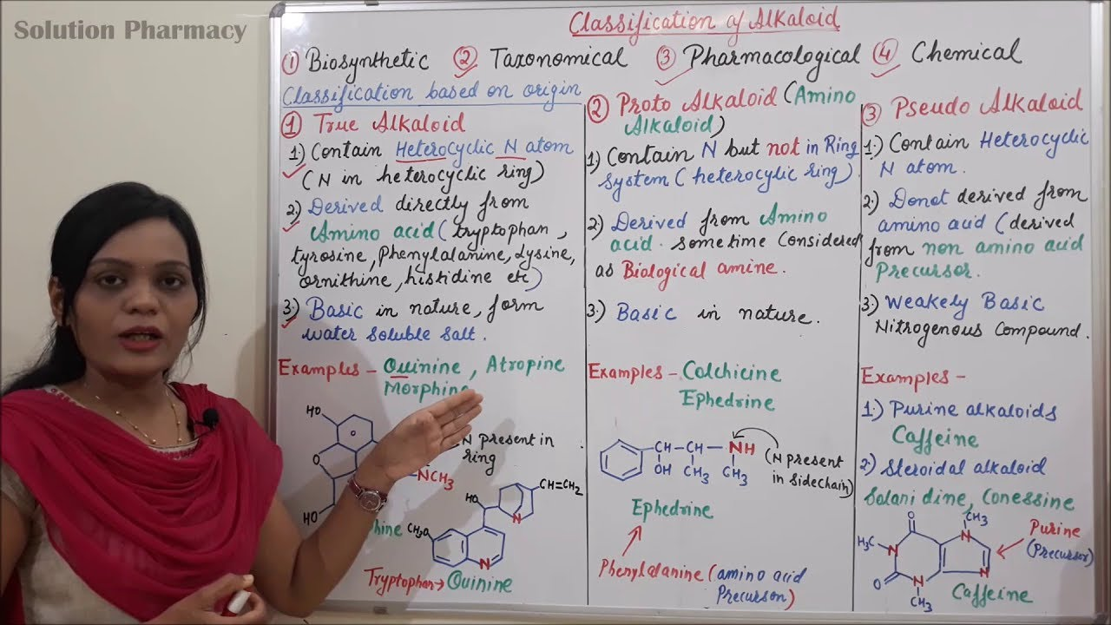

<https://www.google.com/url?sa=i&url=https%3A%2F%2Fm.youtube.com%2Fwatch%3Fv%3DmH1UggSv47k&psig=AOvVaw3xbqI7PRWyoqPUnIdJUXMe&ust=1716958117485000&source=images&cd=vfe&opi=89978449&ved=0CBQQjhxqFwoTCOiQyMHFr4YDFQAAAAAdAAAAABAh>

